1. Website Specifications
1.1 Introduction
This project focuses on the design and development of a modern Gadget Shop Website. The website allows users to browse, compare, and interact with various electronic devices such as smartphones, laptops, and accessories.
The system is designed to simulate a real-world online shopping platform while incorporating interactive features such as a product comparison tool, 3D product viewer, and a checkout system.

1.2 Website Objectives
The main objectives of the website are:
- To design a visually appealing and user-friendly interface
- To provide detailed and structured information about gadgets
- To implement a product comparison feature
- To integrate a 3D product visualization system
- To simulate an online checkout process
- To ensure compatibility across different devices and browsers

1.3 Website Goals
The goals of the website include:
- Providing accurate and organized product information
- Helping users make informed decisions through comparisons
- Creating an interactive and engaging user experience
- Ensuring easy navigation across all pages
- Supporting responsive design for mobile and desktop users
- Incorporating multimedia elements such as images and 3D models
- Allowing users to submit feedback through a form

1.4 Target Audience
Demographics
- Age: 16 – 40 years
- Gender: All
- Occupation: Students, professionals, tech enthusiasts
Technical Ability
- Basic to intermediate computer skills
- Familiar with browsing websites and online shopping
User Needs
- Easy access to gadget information
- Ability to compare products
- Interactive features (3D view, comparisons)
- Mobile-friendly design

1.5 Type of Website
This website is a commercial e-commerce style website that focuses on product display and interaction rather than full online transactions.
It includes:
- Informational content (product details)
- Interactive features (comparison tool, 3D viewer)
- Multimedia elements (images, models)

2. Information Design & Taxonomy

Site flow Chart
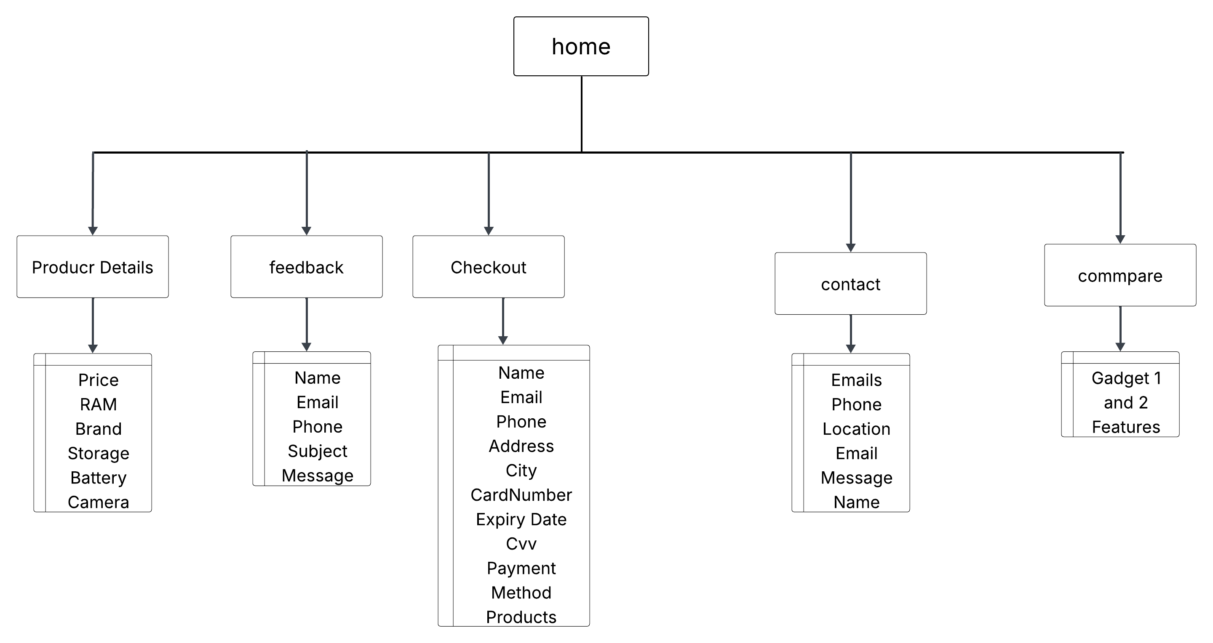
2.1 Site Map

Home
│
├── Shop
│ ├── Smartphones
│ ├── Laptops
│ ├── Audio Devices
│ └── Wearables
│
├── Compare Gadgets
│
├── Product Details
│ └── 3D Viewer
│
├── Contact
│
├── Feedback
│
└── Checkout

2.2 Navigation Design
The website will use a consistent navigation bar across all pages.
Main Menu:
- Home
- Shop
- Compare
- Contact
- Feedback

2.3 Navigation Principles
The website design will follow these usability principles:
- Three-click rule – users reach content within 3 clicks
- Consistency – same layout across pages
- Clarity – simple and clear labels
- Responsiveness – works on all devices

2.4 Content Organization
Products will be grouped into categories:
- Smartphones
- Laptops
- Audio Devices
- Wearables
- Accessories
Each product will include:
- Image or 3D model
- Price
- Specifications
- Description

3. Page Template Design (Wireframes)
3.1 Home Page
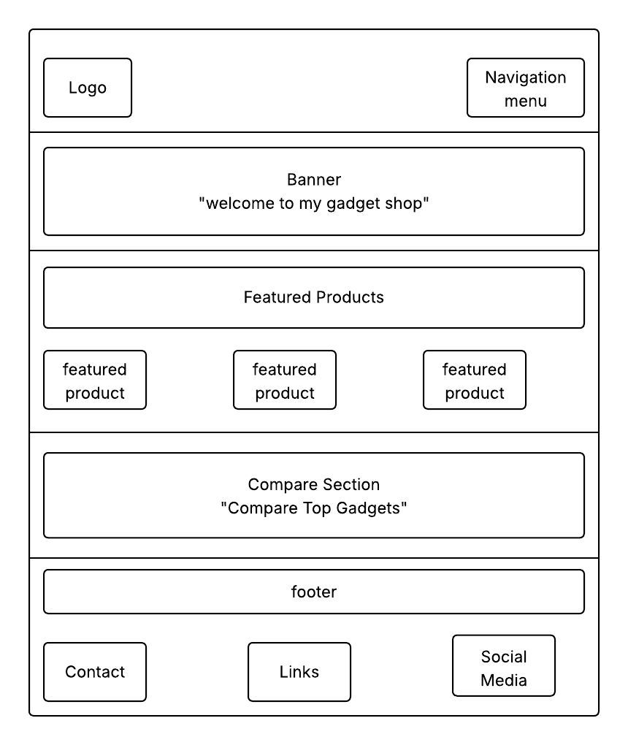

3.2 Product Details Page
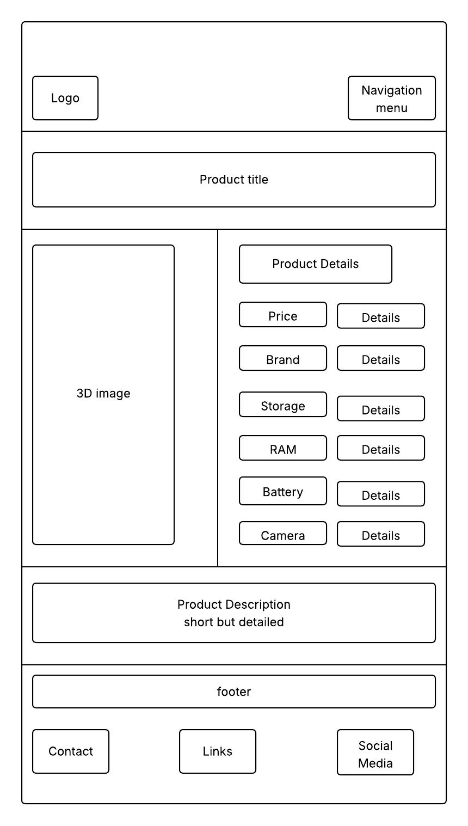
3.3 Feedback Page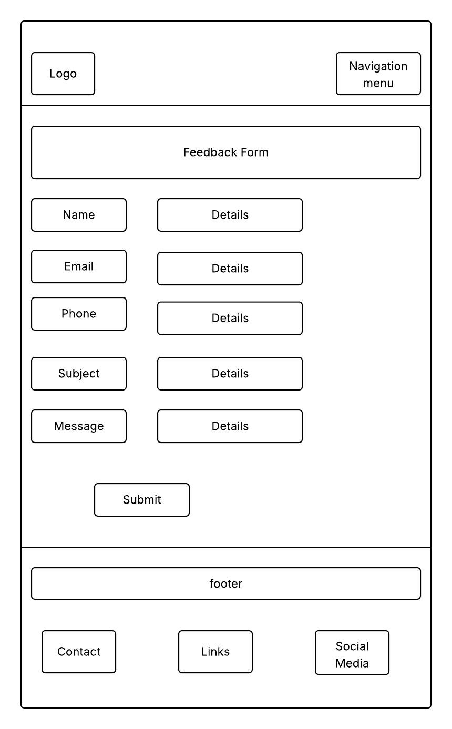
3.4 Contact Page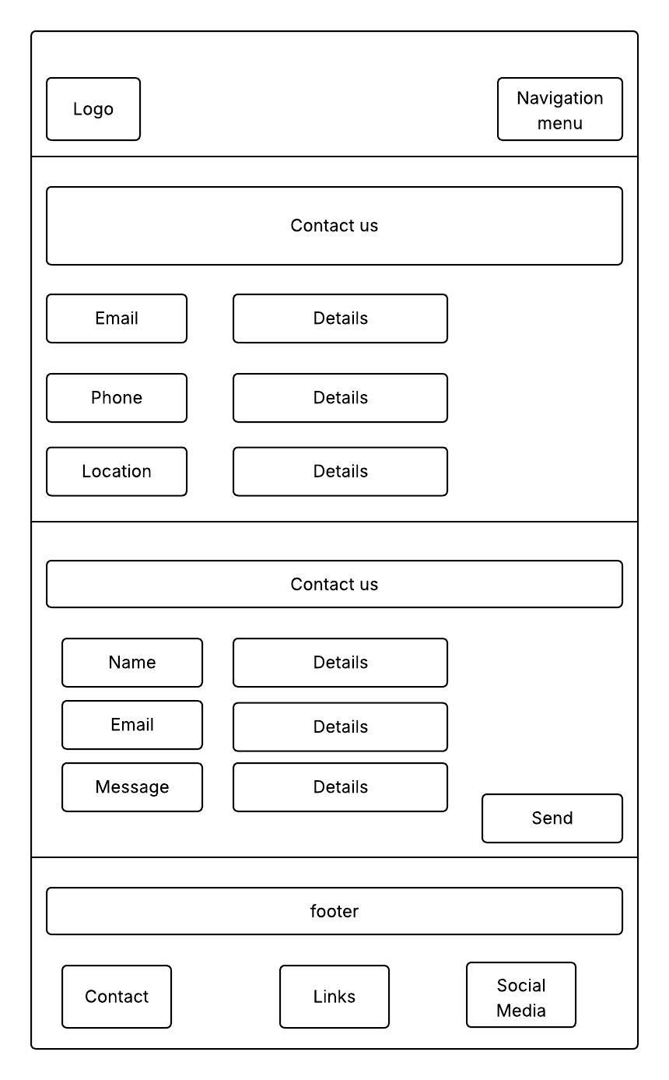
3.5 Checkout Page
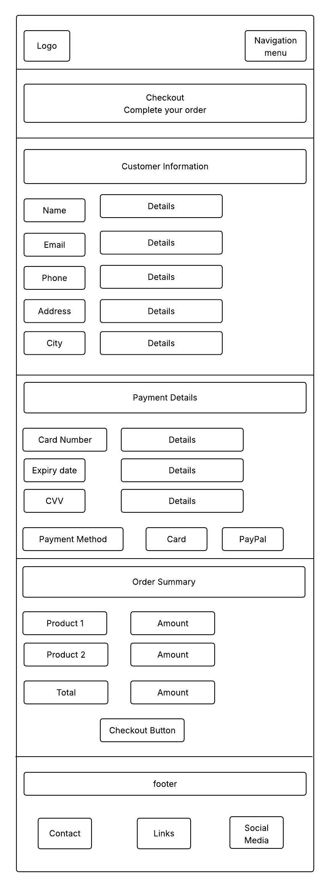
3.6 Compare Page
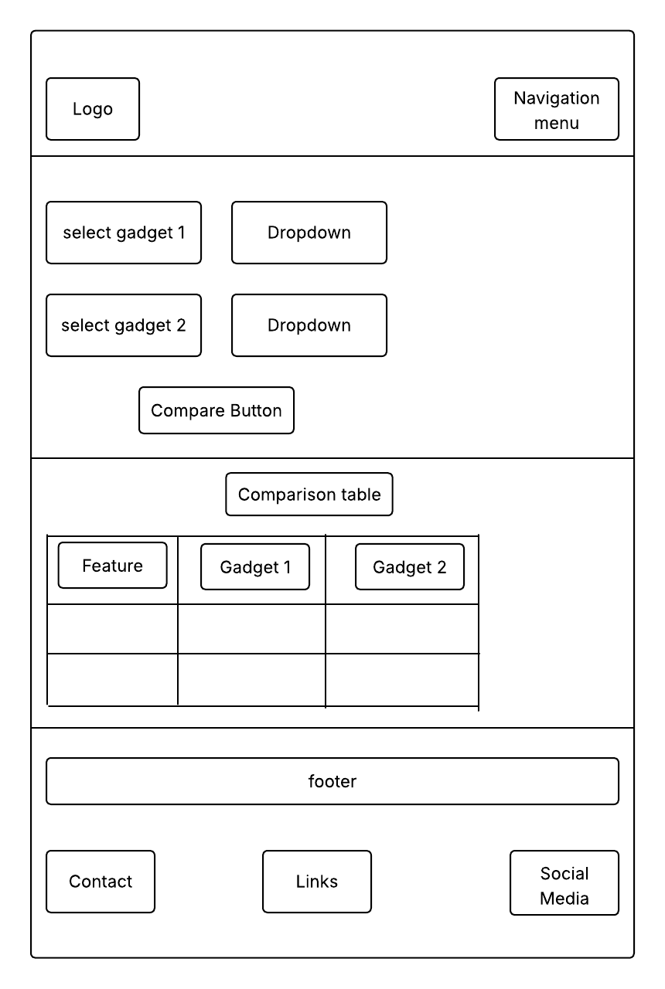

4. Technical Brief
4.1 Technologies Used
- HTML5 – structure of the website
- CSS3 – styling and layout
- JavaScript – interactivity
- Bootstrap – responsive design

4.2 Libraries
- Model Viewer – for 3D product display

4.3 Development Tools
- Visual Studio Code – code editor
- GitHub – version control
- GitHub Pages – hosting
- GIMP – image editing

5. Quality Assurance
5.1 Testing Methods
- Browser testing (Chrome, Firefox, Edge, Safari)
- Device testing (desktop, tablet, mobile)
- Functional testing (forms, navigation, compare system)
- Performance testing (loading speed)

5.2 Expected Results
- No broken links
- Responsive layout
- Functional forms
- Consistent design across browsers

6. Publishing & Promotion
The website will be hosted using GitHub Pages.
Steps:
- Create a GitHub repository
- Upload files
- Enable GitHub Pages
- Publish website
URL:
https://username.github.io/gadget-shop

7. Future Developments / Recommendations
The website can be improved by adding:
- Shopping cart functionality
- Online payment integration
- User login system
- Product reviews and ratings
- Database integration
- AI-based recommendations

